Early Childhood Action Plan
Toolkit for Document Update 2019

1. Research and Evidence Informed
What changes are needed to address gaps and unmet needs informed by data and research; in particular PDG Needs Assessment?
Do we have information telling us this is a best practice?
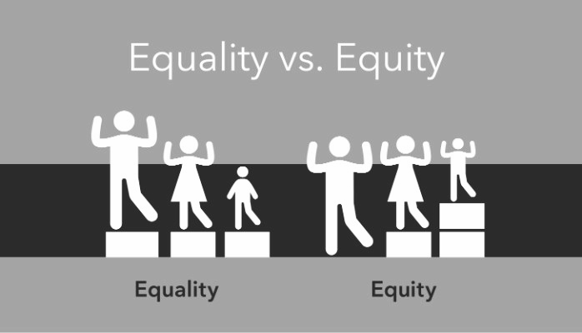 | 2. Promotes Equity  What changes are needed to increase opportunity for those who historically have been excluded and reforms the ways in which institutions operate to lessen disparities and eliminate discrimination?
3. Support the Full Participation of Each and Every Child and Family
What practices are needed to support children of diverse cultures, languages, abilities, and life circumstances?
What efforts will engage their families?
4. Measurable
Is this measurable using a Results Based Accountability framework to measure impact over time?
Do we have information telling us this is a need?
Do we have disaggregated data to track potential inequities?
5. Coordinated
Are we creating a process that facilitates collaboration among divers partners and across sectors, coordination, and policy alignment to leverage existing and new resources efficaciously in Vermont’s Birth-Eight system?
6. Leverage
Are there outdated or completed strategies?
How can we strengthen strategies to use clear language, are timely, doable and build on current strengths and assets?

Note taking form

Result # Name of note taker:
1.What has been fully or partially accomplished or is no longer relevant?
(cite Result, Strategy and Activity)

2.Review the ECAP using the tool on p. 1 with the 6 areas on how to strengthen the ECAP to be: research and evidence Informed; promotes equity; support the full participation of each and every child and family; is measurable; promotes coordination, and leverages resources/other opportunities.
Identify area that needs work or particular attention by committees (cite Result, Strategy and Activity)

3.Parking Lot (to capture ideas, questions or suggestions that are a bit off topic. This list can get sorted and sent to committees)

How to use this tool with a group

About the process-Today we are testing a tool that will be used for ECAP committees. It’s a play-within-a-play and there will be time to give feedback on what worked and what needs to be improved. If you are part of an ECAP committee, your participation will help facilitate this process with your committee.
- Identify a facilitator, time keeper and a note taker
- Have copies of the original ECAP (full or section you are reviewing)
- Explain this is an opportunity to gather input from a diverse group on what needs to be changed in the ECAP. The Results and strategies will stay the same, it is the action steps that need review.
- Give people 5 minutes to read the materials and just note what areas they think need group discussion.
  - ECAP Tool with 6 areas on how to strengthen the ECAP
  - Result area you are examining at this time
  - Other supporting documents you have identified
- Manage your time: Before you dive into discussion, survey how many items people identified in their solo 5 minutes that will require some group attention. This will help you plan your time. Avoid having deep discussions or wordsmithing on one item at the expense of no time for others.
- Use the note taking form to capture
  - What has been fully or partially accomplished or is no longer relevant?
  - Use the 6 areas on how to strengthen the ECAP to tag areas for improvement
  - How can be more explicit to better support the child/family persona you read at the beginning of the meeting?
- Use a ‘parking lot’ to capture ideas, questions or suggestions that are a bit off topic. This list can get sorted and sent to committees
- In the last 5 minutes, summarize your discussion, agreements and outstanding questions
- After the first small group, we will reconvene to reflect how this process went and how it can be improved. There will be a short break and then we will divide into new small groups

