Building Bright Futures Professional Preparation and Development Committee
Proposed Tools and Resources
March 28, 2018

Decision-Making Tool for Seeking Agreement: The BBF PPD committee utilizes modified consensus to seek agreement. This modified consensus process will utilize a decision-making tool (red yellow and green cards) to indicate levels of agreement with various proposals brought before the committee. We currently use the following levels of agreement:
Green is Consent: Holding up a green card indicates your general agreement, support for, and willingness to abide by the proposal.

Yellow is Consent with Reservations: Holding up a yellow card indicates you have some concerns with the proposal. The group will make every effort to address these concerns in a way that helps you feel confident moving to Green. If the group is unable to resolve your concerns, you are still willing to allow the proposal to move forward and will not block.

Red is Block: Holding up a red card indicates you have serious concerns with the proposal and you do not feel comfortable allowing it to move forward. The group will make every effort to address these concerns in a way that helps you feel confident moving to Green. At minimum, the group will work to address these concerns in a way that allows you to feel confident moving to Yellow.

Proposed Meeting Ground Rules:
- Take responsibility for your own learning
- Participate by sharing your own opinions and experiences and those of the people you represent
- Listen to and consider the opinions of others
- Honor confidentiality requests
- Challenge yourself to think about creative solutions
- Assume positive intent

Levels of Involvement in Decision Making
There will be times when BBF PPD is not the final decision-maker about a particular issue and will instead be making a recommendation to a person, committee, organization, or agency who has final say in the decision itself. For these decisions and recommendations, we will strive to provide BBF PPD members with detail about who is the final decision-maker and clarify the particular role of BBF PPD membership.

Please see the following chart for further detail:

Levels of Involvement in Decision Making
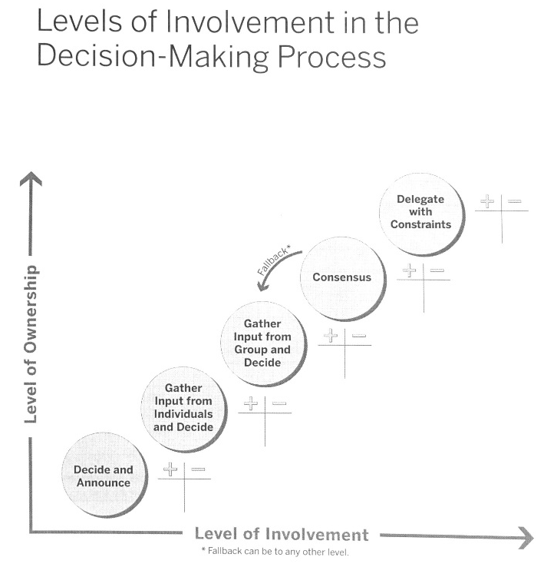

Factors to consider:
- Stakeholder buy-in
- Time available
- Importance of decision
- Information needed
- Capability
- Building teamwork

Decide and Announce
Leader makes the decision with little or no input, then announces the decision to those who will be affected by or must carry out the decision.

Gather Input from Individuals and Decide
Leader asks selected individuals for input (ideas, suggestions, information). The leader then makes a decision.

Gather Input from the Team and Decide
Leader asks the team members to share their ideas in a meeting. The leader decides after hearing from the team.

Consensus
A consensus decision is one that every member of the team is willing to support and help implement. All Key Stakeholders have had an opportunity to give their opinion and to understand the implications of various options. All members, including the Leader, have the same formal power to support or block proposals. If consensus cannot be reached, the leader has a fallback decision-making option.

Delegate Decision with Constraints
Leader defines the decision that needs to be made in the form of a question, clarifies the constraints on the decision (e.g. budget, timeframe, quality requirements) and delegates the decision to others. The leader does not alter the decision as long as it adheres to the constraints.

